Experiment purpose:  xx | Results:  xx
Draw your molecule using
Link: https://molview.org/
Copy paste in the table below

Starting material | Reagents | Product
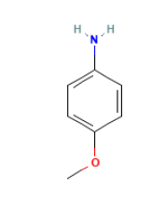 | NaBH4  THF  H2O  H2SO4  —> | 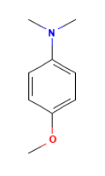

Bibliographic references:
Paste your bibliographic reference using BibTex from google scholar and paste in bibtex converter.
Link: https://asouqi.github.io/bibtex-converter/

Reagents:
N. | Reagents | Approx. Equivalents | Approx. mmol | Weight (g) | Volume (mL) | Density | Assay wt* | MW:
1
2
4
5

Procedure:
xx

Pictures:

Handnotes:

